Network Load Balancing

**Michael Kohronas**

**10/30/2023**

**Project Portfolio: III**

Contents

Step 1: Install Active Directory Domain Services & Set it up 3

Step 2: Remove Duplicate SID & Generate a new SID 4

Step 3: Connect NLB-ServerB to NLB-ServerA 5

Step 4: Install Web Server (IIS) and Network Load Balancer (NLB) 7

Step 5: Setup the Network Load Balancer (NLB) 7

Step 6: Create a nbl folder & html file and 8

Step 7: Step up Internet Information Services (IIS) 9

Step 8: Add the IP Address and Host Name to the hosts file 9

Step 9: Completed 10

# Step 1: Install Active Directory Domain Services & Set it up

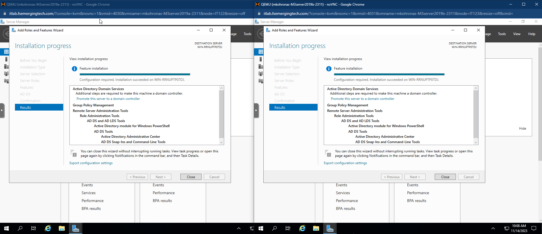

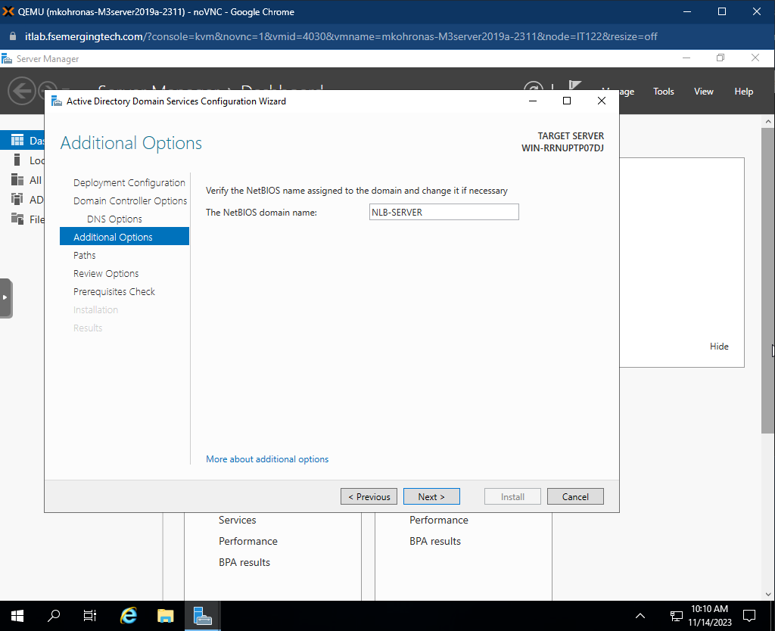

# Step 2: Remove Duplicate SID & Generate a new SID

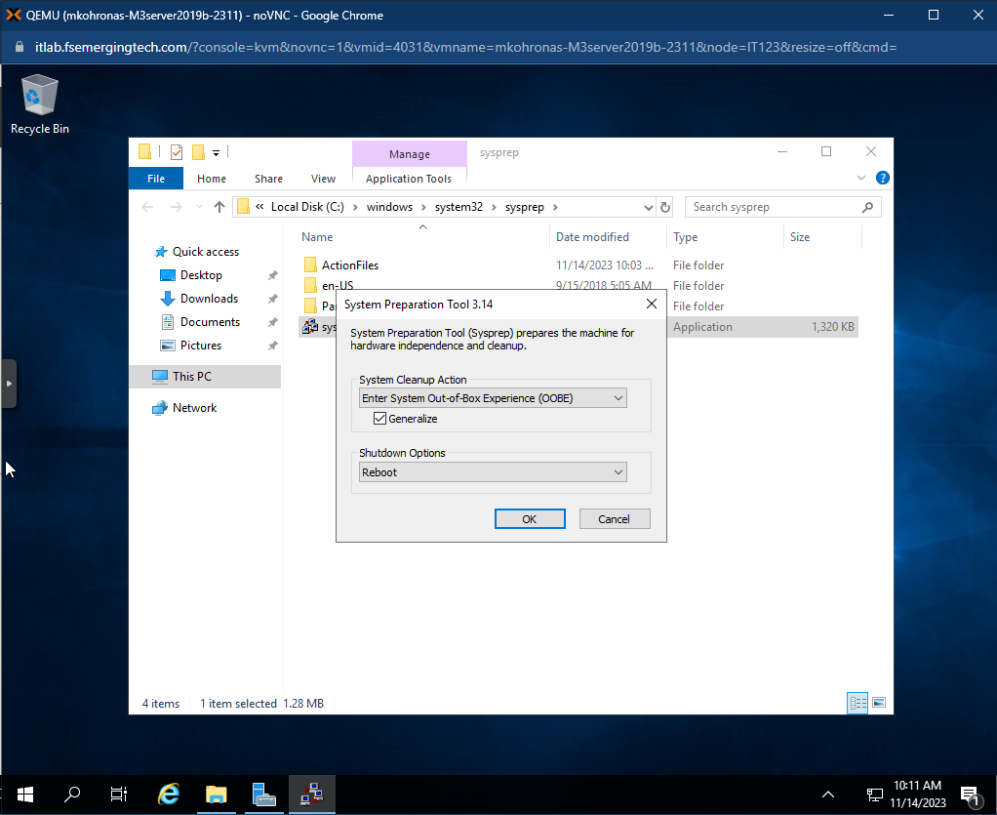

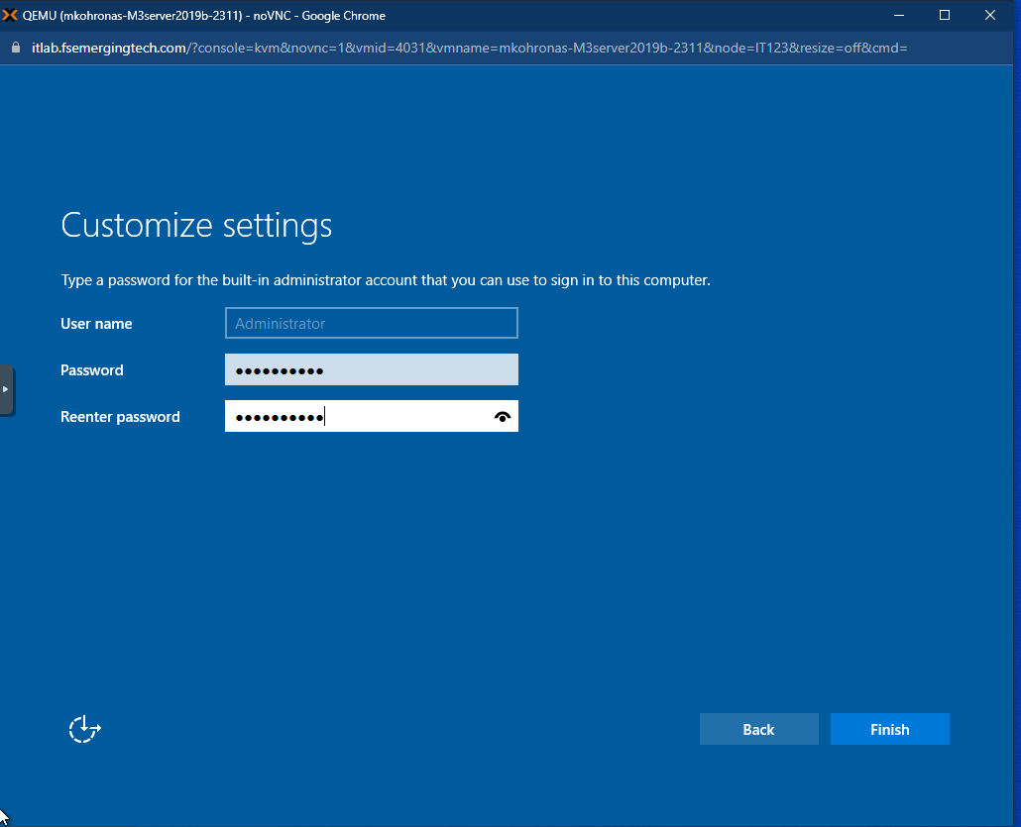

# Step 3: Connect NLB-ServerB to NLB-ServerA

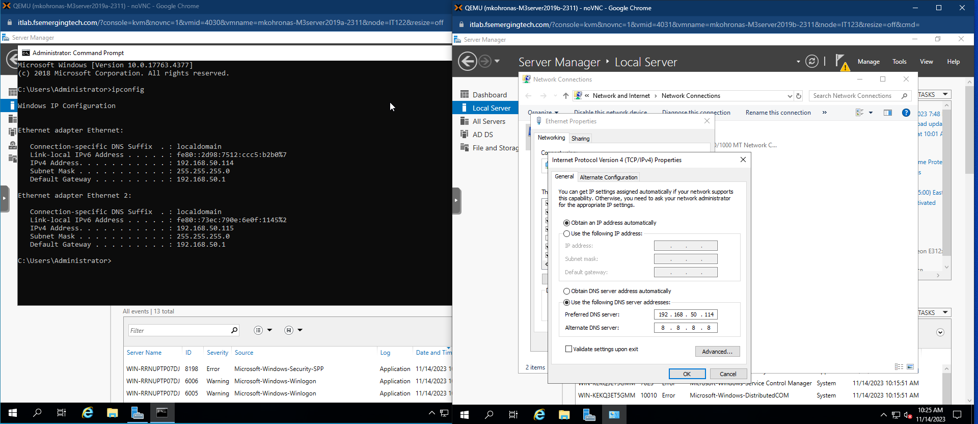

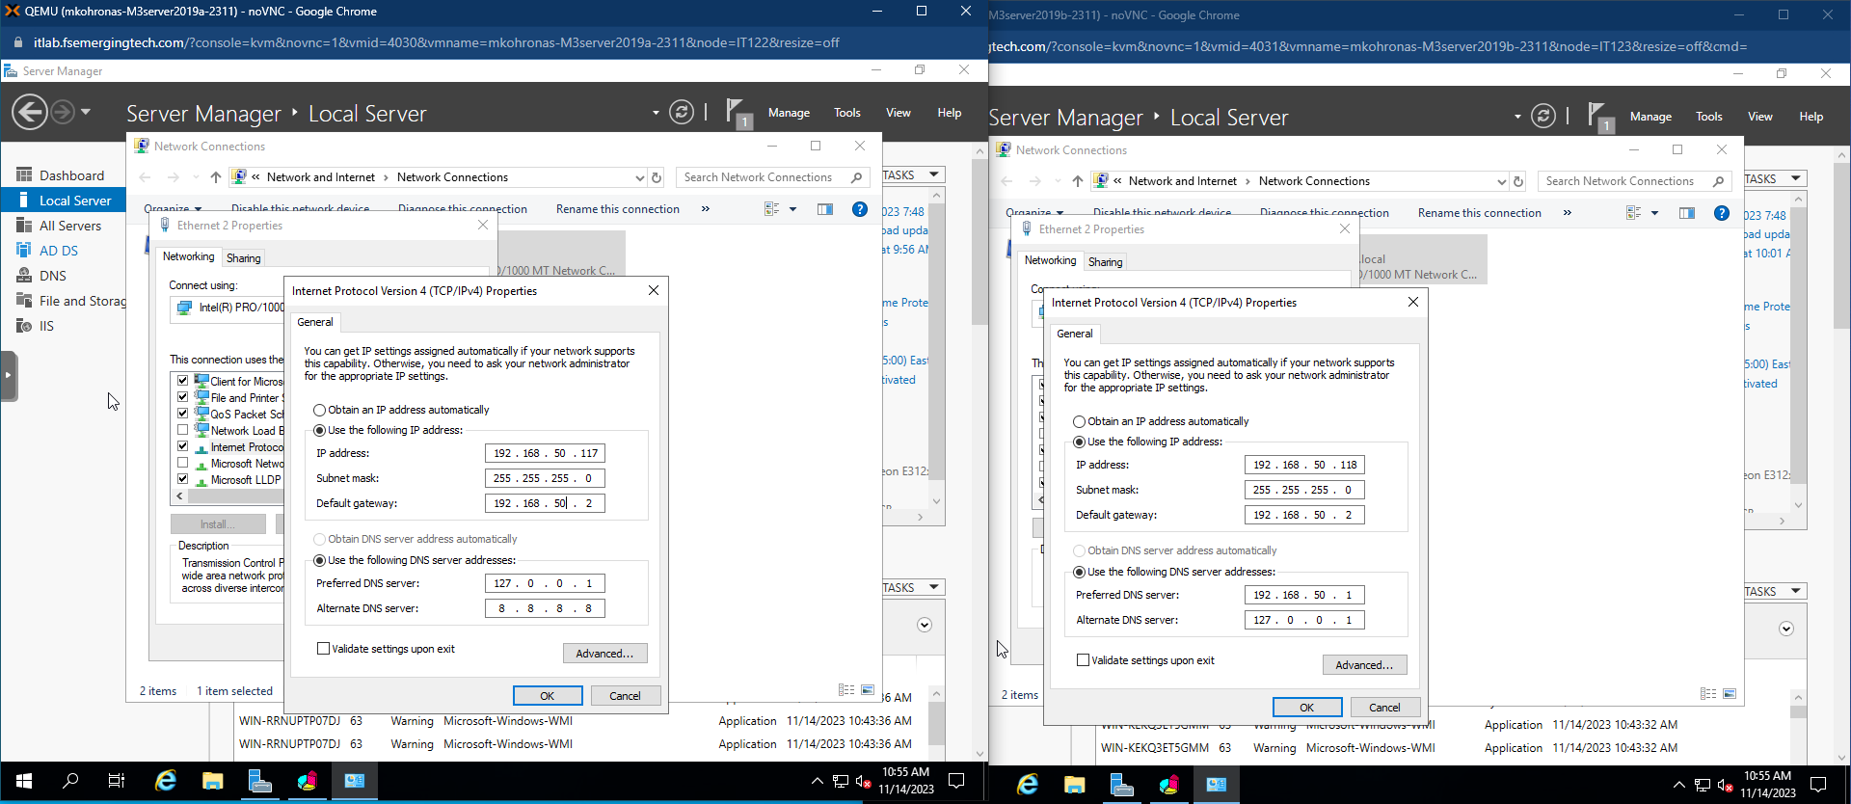

# Step 4: Install Web Server (IIS) and Network Load Balancer (NLB)

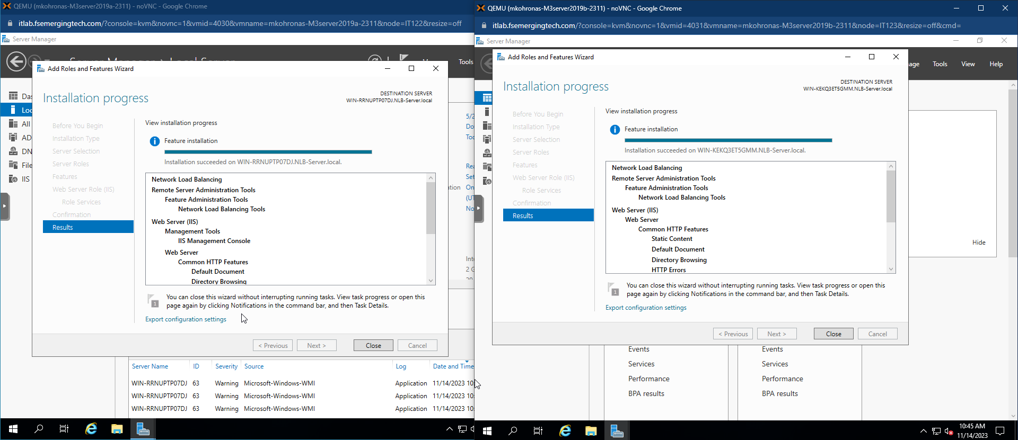

# Step 5: Setup the Network Load Balancer (NLB)

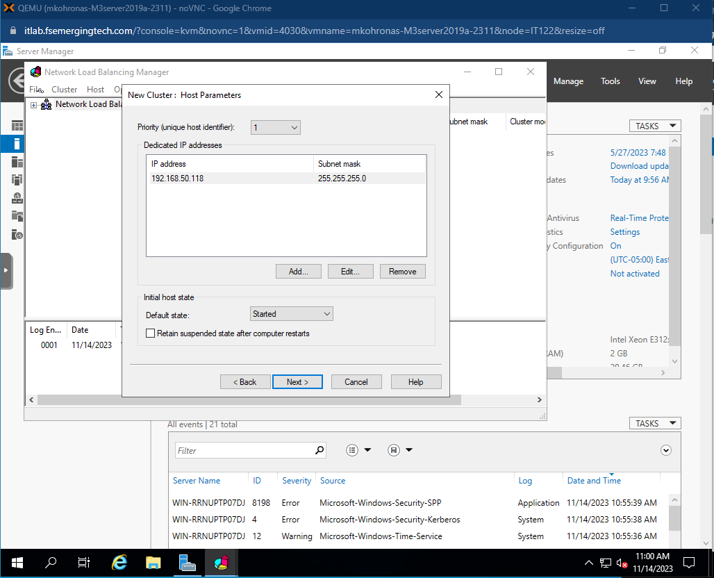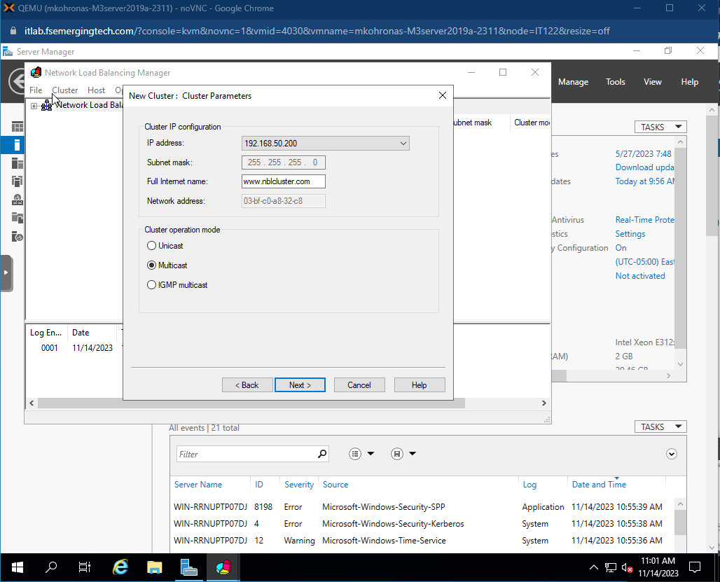

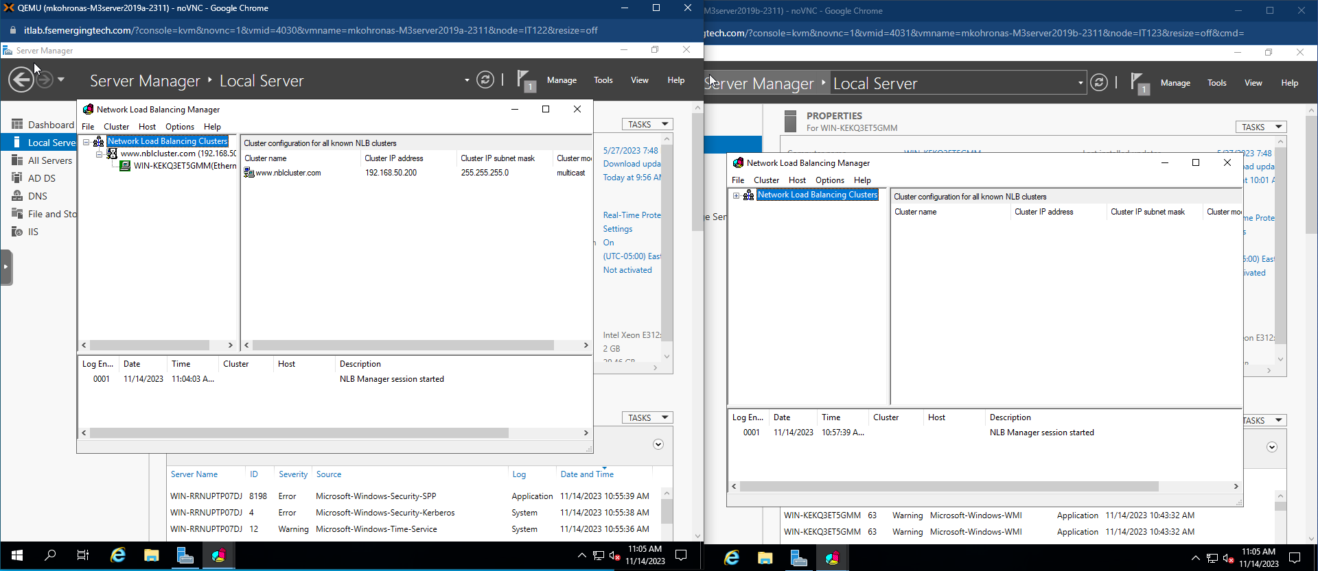

# Step 6: Create a nlb folder & html file and move it to the wwwroot folder

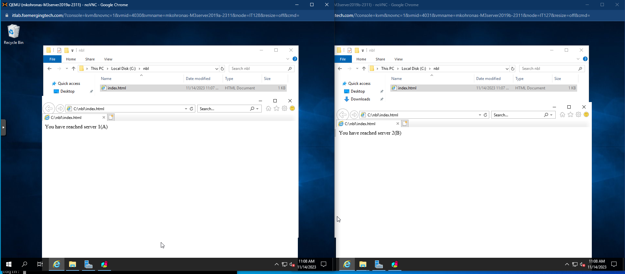

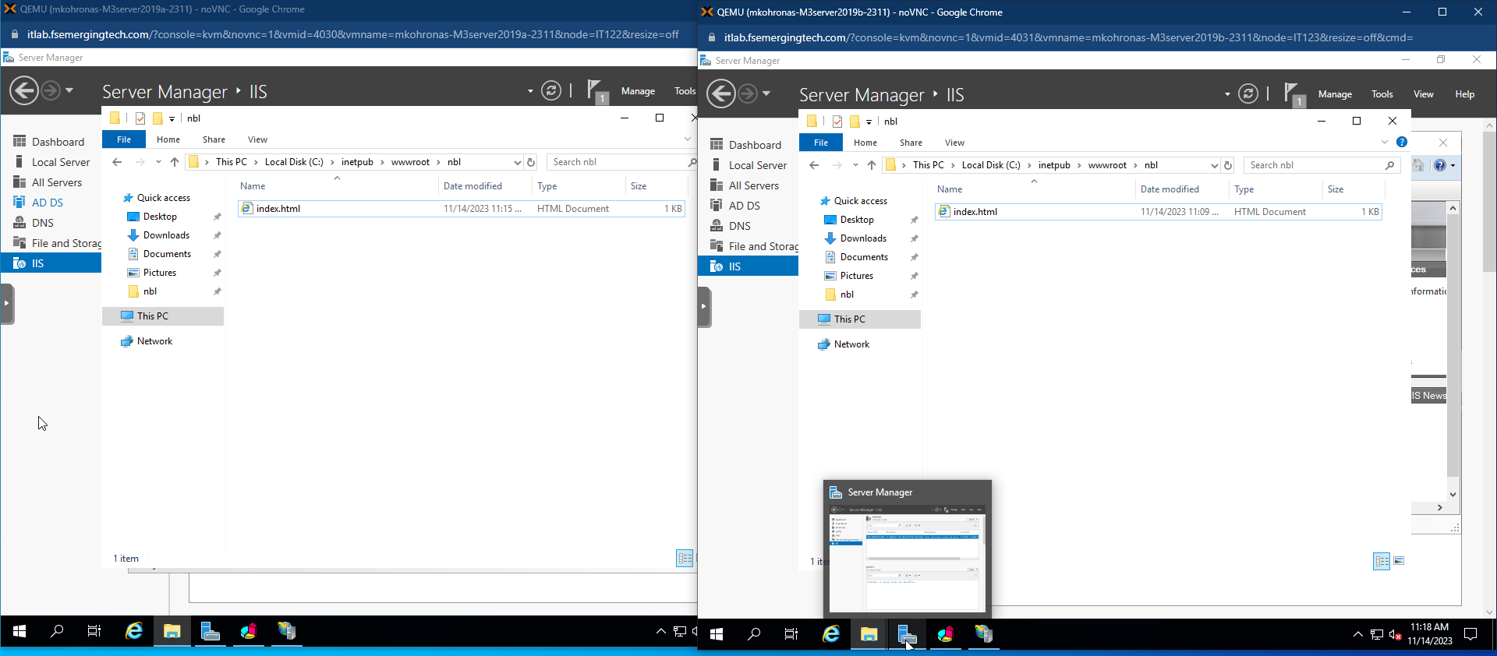

# Step 7: Step up Internet Information Services (IIS)

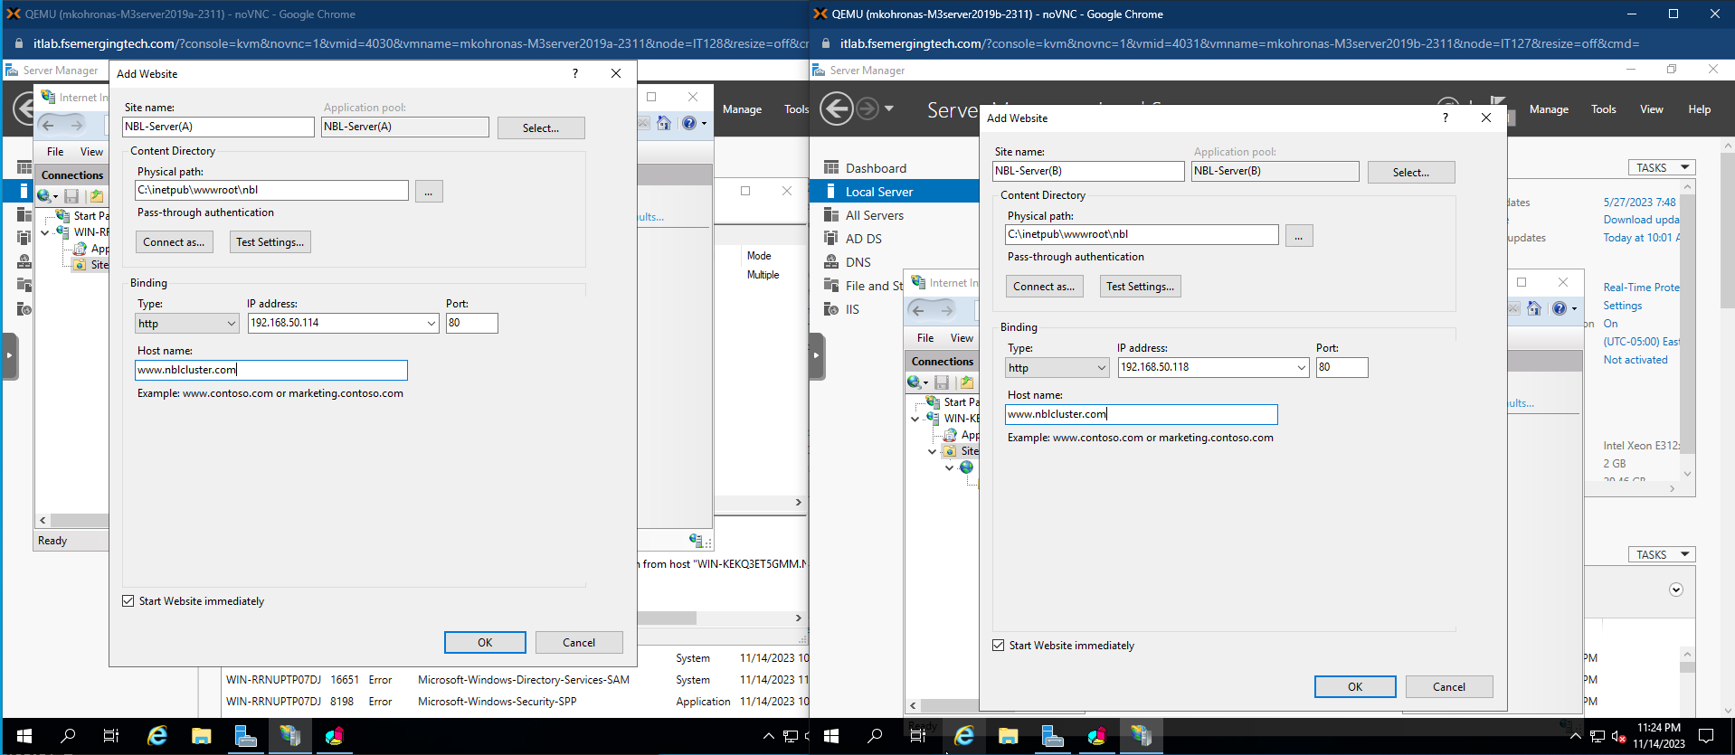

# Step 8: Add the IP Address and Host Name to the hosts file

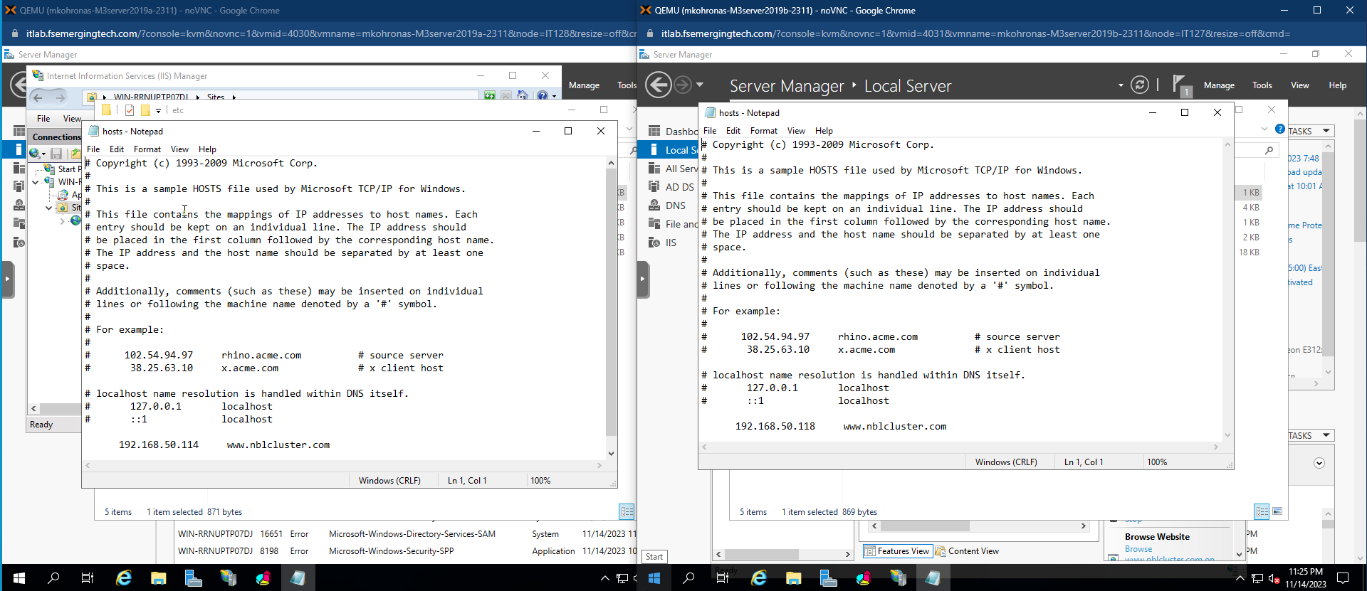

# Step 9: Access [www.nblcluster.com](http://www.nblcluster.com) on both VM’s

